Experiment 3

1.Take a command line argument and report on whether is a directory or a file

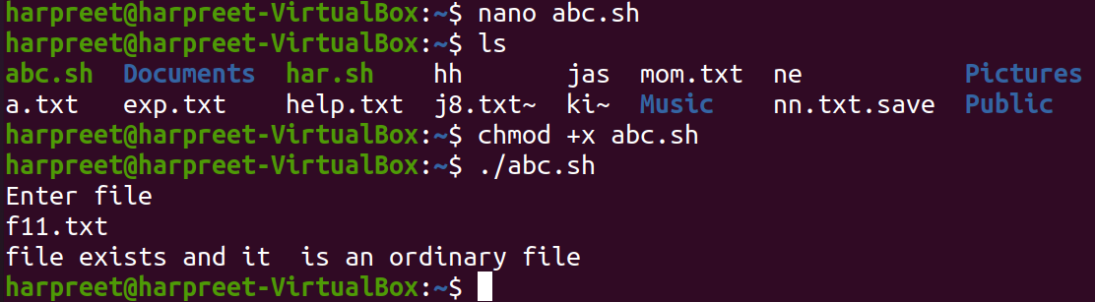

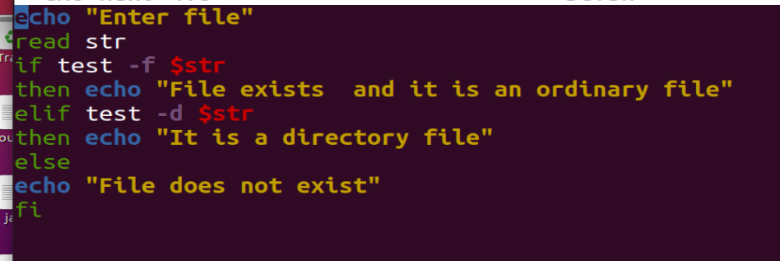

2.Takes the filename as argument and convert all of them to uppercase

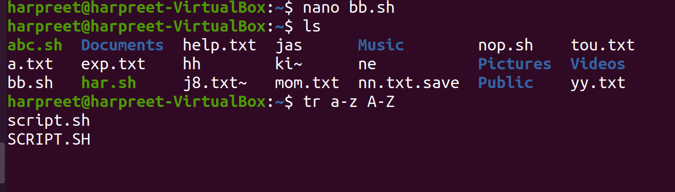

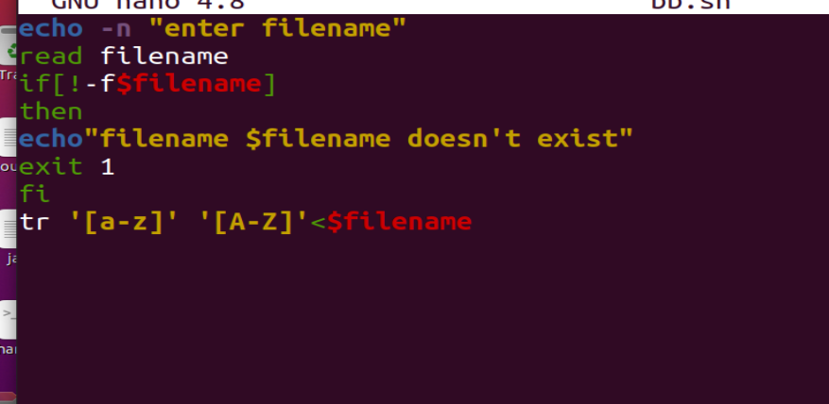

3. Write a shell script that captures the number of command line arguments and displays arguments supplied by the user. Using grep command ,we have to search string entered as argument1 in file entered as argument2

